

26-B, Abdul Rasheed Plaza, Multan. Ph: 061-6791276

***Ref: Date:***



AQSA Security Service

(Pvt.) Ltd Multan

**TO WHOM IT MAY CONCERN**

It is certified that Mr. <Name> S/o <fname> worked in Aqsa Security Services (Pvt.) Limited Multan as a <Designation> from   
<From2> to <To2> at “UBL Bank Nawan Shaher Branch Multan”.

During his stay in our organization we found him hard working and having a good moral character. We have no objection on his doing work at any where.

We wish him best of luck for his success in his future life.

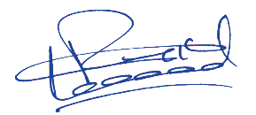

Arshad Bhatti Security Incharge